SQL Based Project: Pizza Sale

**By SIDDHARTHA SRIVASTAVA**

**Date: 01-01-2025**

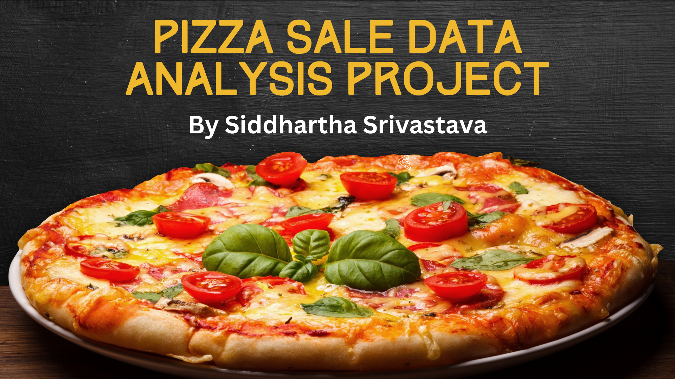

How Our Tables Are Connected To Each Other

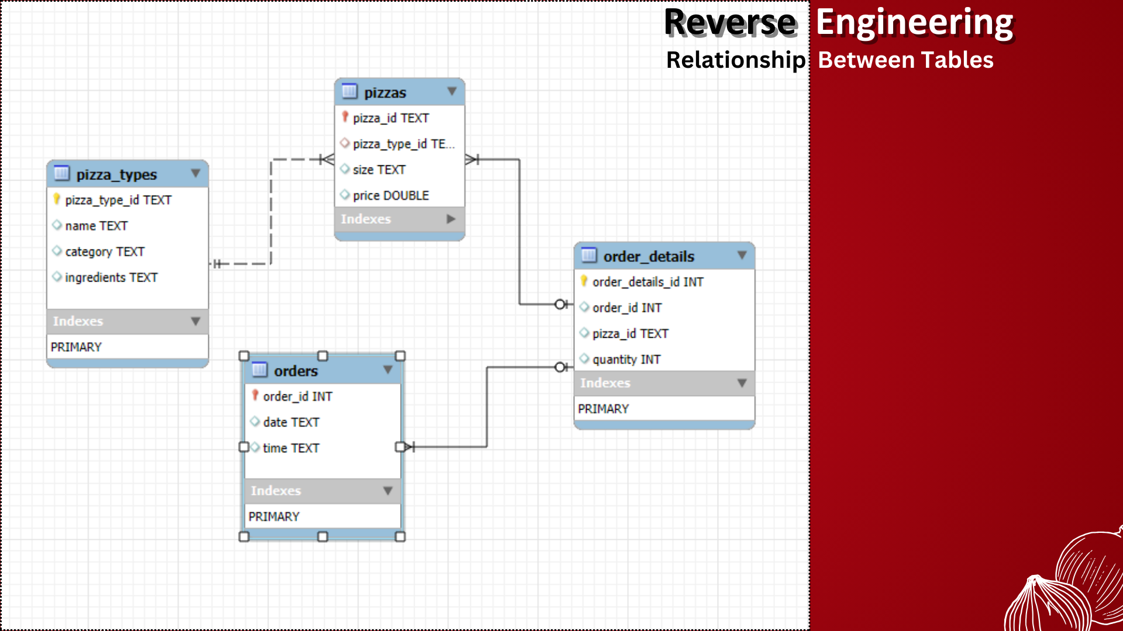

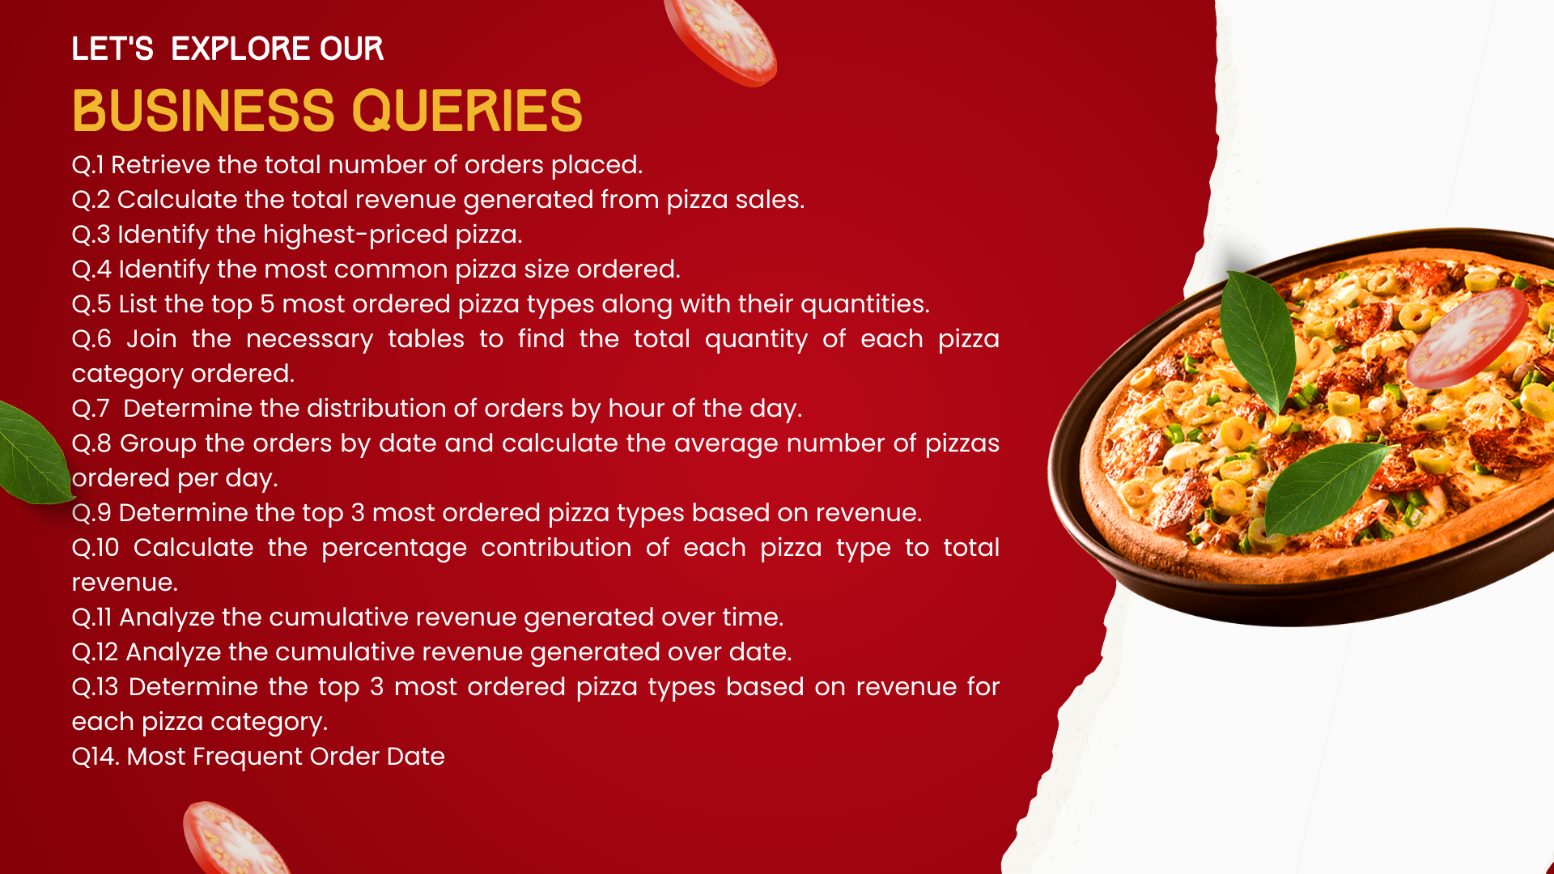

**Here Are Our Finding As Per Our The Queries Given To Solve**

